Chapter 8 programming

8.21:

a) 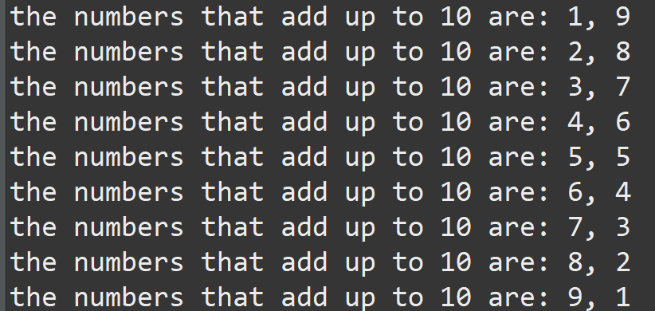

b)

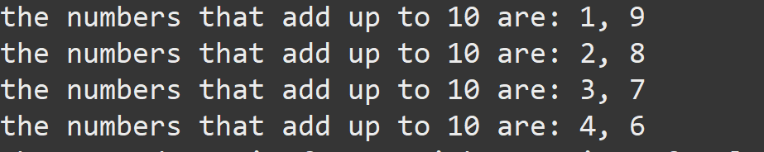

c)



8.27:

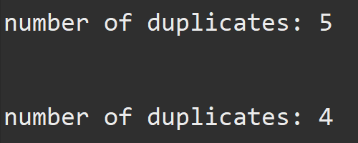

Integer[] arr2 = {1, 1, 3, 4, 4, 6, 7, 7, 7, 7};

Integer[] arr3 = {7, 1, 1, 7, 4, 6, 7, 7, 7, 7, 1};

8.33:

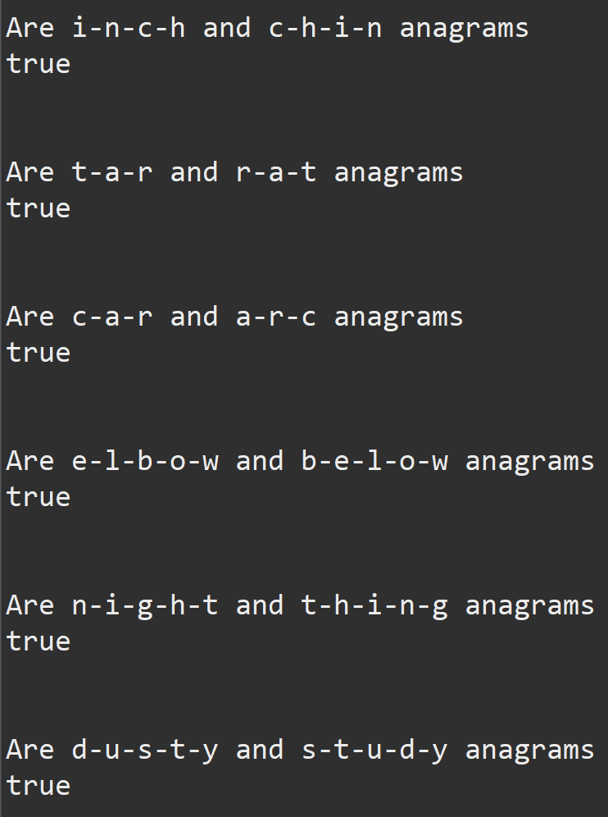

I tried using .split but the only way I could do it is by putting – between each letter in the word to split it into the array.